All Evaluation Reports

This article provides information on all of the available Vector Evaluations+ reports and how to run them.
- Dec 12, 2023
- Knowledge
Article Body
Contents: Progress Reports | Total Recorded Data | Progress Tracking Detail | Forms Submitted by Due Date | Observation Reports | Observations by Evaluator | Observations by Evaluee | Detailed Report | Performance Reports | Ratings By Question | Ratings by Tag | Search Data | Quick Search | Export Form Data | Schools | School Total Recorded Data | Plans | Plan Completeness Report | User Activity | User Logins|
Vector Evaluations+ provides users with a rich set of reports and dashboards that enable you to make data-driven decisions and monitor progress and compliance throughout the evaluation process. From teacher to evaluator to district office staff, reports and dashboards are customized to meet your individual needs. You can view, print, and export reports to meet your needs.
When you want to run a report you would first click on the Reports Icon on the left-hand side of the page when you are logged in 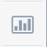
From here you will see drop downs of all the different reports available to you which are all described in further detail below:
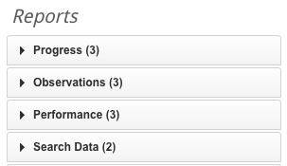
For all reports you can use the filters as well as the Advanced Filters if you need to run reports on specific groups:
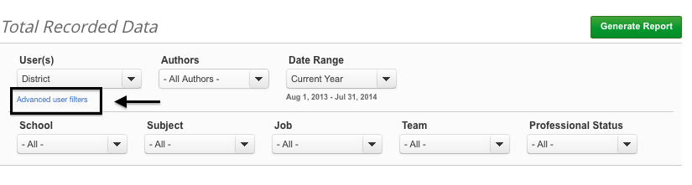
You can also select a group
NOTE: You will only be able to run reports on data that you have permission to view, so educators without evaluator permission will only be able to run reports on their own data which limits which reports you can see. If you are an evaluator you will only be able to see data from yourself and your evaluees.
Back to top

Progress Reports

Total Recorded Data
Who can run this report: Teachers, Evaluators, District Administrators
Description: This report allows you to see the total number of recorded forms and uploaded files for the selected Evaluees. This includes data recorded by all Evaluators.
Filters: User(s), Authors, Date Range
Advanced Filters: School, Subject, Job, Team, Professional Status, Department, Region
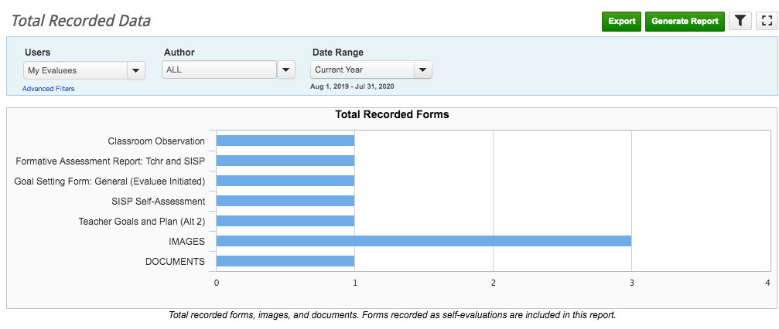
* You are able to export this report into a CSV document to further manipulate the data
Back to top

Progress Tracking Detail
Who can run this report: Evaluators, District Administrators
Description: You can see a list of all users and the forms that they completed/did not complete. You can track form completion for evaluees, selected form or all forms. It indicates when the form was created, last modified an if it had been shared and signed.
A form must have been at least created in order for it to show up on this report.
Filters: User(s), Authors, Date Range, Form Name
Advanced Filters: School, Subject, Job, Team, Professional Status, Department, Regions
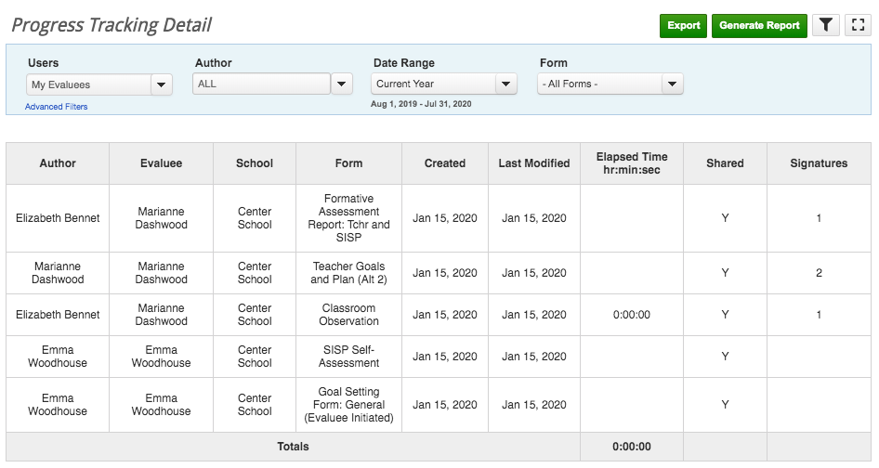
* You are able to export this report into a CSV document to further manipulate the data
Back to top

Forms Submitted by Due Date
Who can run this report: Evaluators, District Administrators
Description: Set a due date and choose multiple forms to see a list of users who have submitted or completed the form on time.
- A form is considered Submitted once it is shared and signed by the author (if a signature is required).
- A form is considered Completed once it is shared and all required signatures are placed.
- The pie chart lets you see the visual representation of users who have Submitted or Completed the forms on time.
Filters: User(s), Authors, Due Date, Form Name
Advanced Filters: School, Subject, Job, Team, Professional Status, Department, Regions
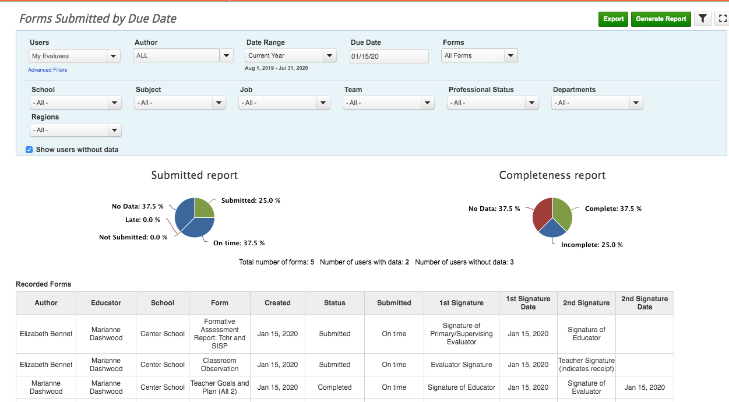
Note: By checking the box "Show users without data" the names of those evaluees who have not created the selected form(s) yet.
* You are able to export this report into a CSV document to further manipulate the data
Back to top

Observation Reports

Observations by Evaluator
Who can run this report: Evaluators, District Administrators
Description: This report will provide a list and graphic of observations performed by Evaluators, as well as a list and graph of how long each observation was if the timer feature is active in your district.
Filters: User(s), Authors, Date Range, Forms
Advanced Filters: School, Subject, Job, Team, Professional Status, Departments, Regions
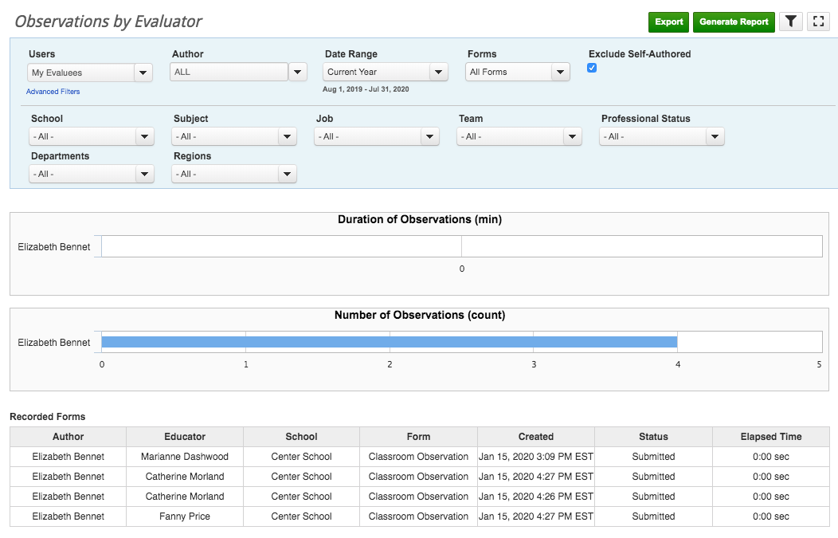
* You are able to export this report into a CSV document to further manipulate the data
Back to top

Observations by Evaluee
Who can run this report: Evaluators, District Administrators
Description: Provides a list of all evaluations per evaluee. A graph will also appear to give a visual on how many evaluations an evaluee has received. A graph of how long each evaluee has been observed for will also appear if the observation timer feature is active in your district.
Filters: User(s), Authors, Date Range, Forms
Advanced Filters: School, Subject, Job, Team, Professional Status, Departments, Regions
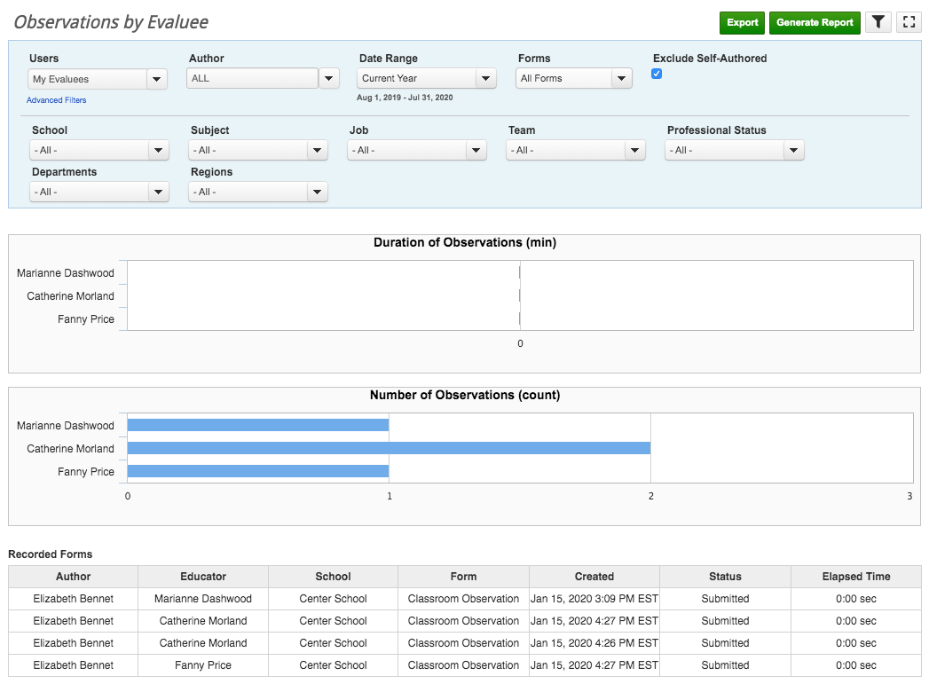
* You are able to export this report into a CSV document to further manipulate the data
Back to top

Detailed Report
Who can run this report: Teachers, Evaluators, District Administrators
Description: Gives a high-level overview of answers associated with a particular form. This will allow you to track and compare how you are answering questions for evaluees, as well as give an overview of evaluee progress. E.g. If an Evaluator filled out multiple Classroom Observation forms about a Teacher you can see how many times a particular answer was selected and determine areas for improvement.
* Self-Evaluation Forms are not included in this report.
Filters: User(s), Date Range, Form Name (have to choose one form)
Advanced Filters: School, Subject, Job, Team, Professional Status, Departments, Regions
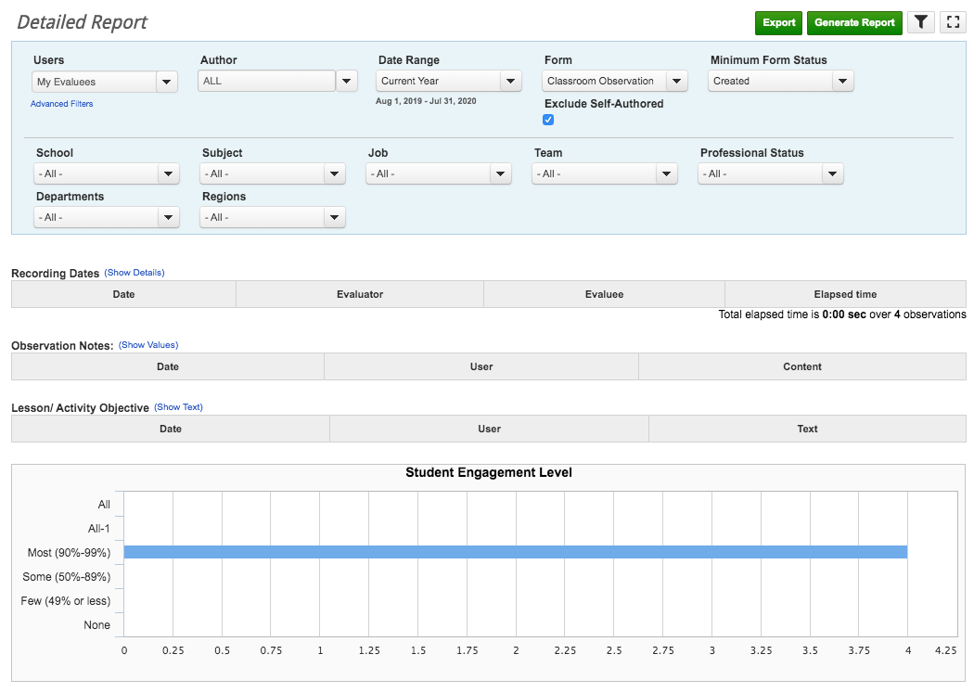
* You are able to export this report into a CSV document to further manipulate the data
Back to top

Performance Reports

Ratings by Tag
Who can run this report: Evaluators, District Administrators
Description: See a list of all users and their performance in rating scale questions.
Filters: User(s), Date Range, Forms, Minimum Form Status, Exclude Self-Authored, Tags, Tag Level, Show Users Without Data
Advanced Filters: School, Subject, Job, Team, Professional Status, Departments, Regions
*In order for the report to generate data the Form has to be tagged by a System Administrator.
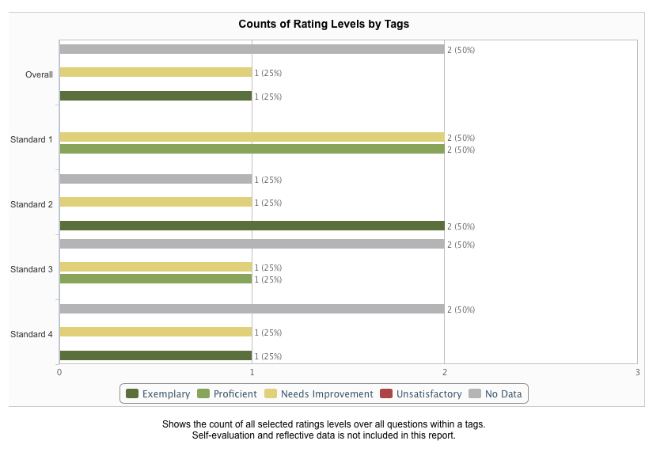

* You are able to export this report into a CSV document to further manipulate the data
Back to top

Ratings by Question
Who can run this report: District Administrators
Description: See how many times a rating level was selected in Standard I rating scale questions.
Filters: User(s), Date Range, Forms, Minimum Ford Status, Exclude Self-Authored, Tags, Tag Level
Advanced Filters: School, Subject, Job, Team, Professional Status, Departments, Regions
*In order for the report to generate data the Form has to be tagged by a System Administrator.* You are able to export his report to further manipulate the data
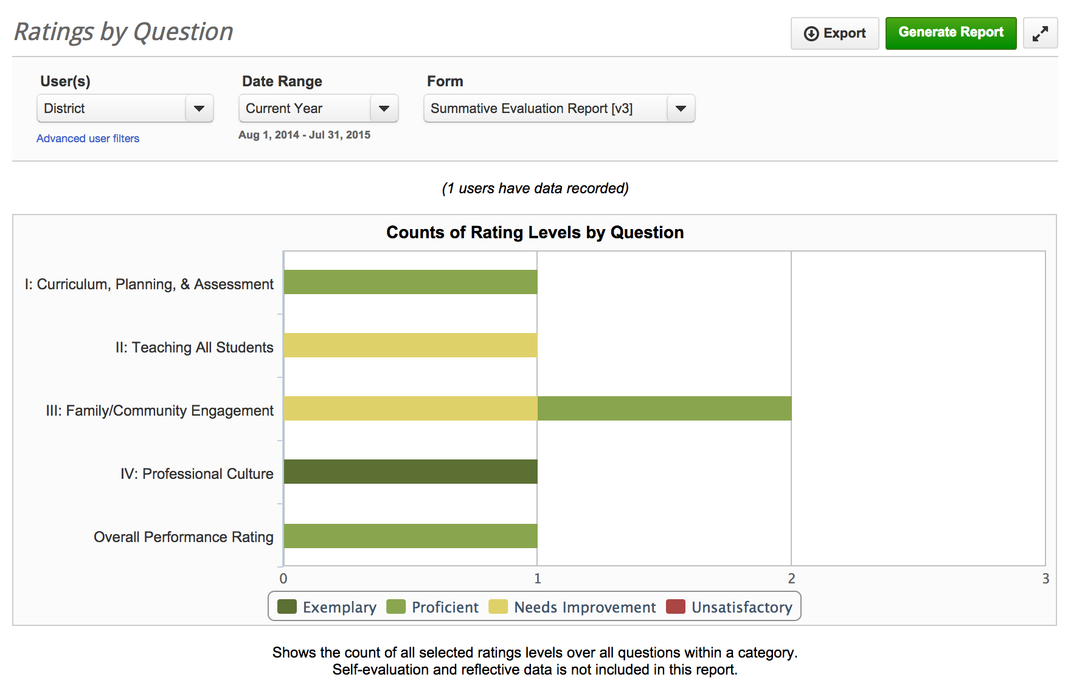
Back to top

Performance Comparison by Tag
Who can run this report: Evaluators, District Administrators
Description: See a list of all users and their performance in rating scale questions.
Filters: User(s), Date Range, Forms, Minimum Form Status, Exlcued Self-AuthoredTags, Tag Level
*In order for the report to generate data the Form has to be tagged by a System Administrator.
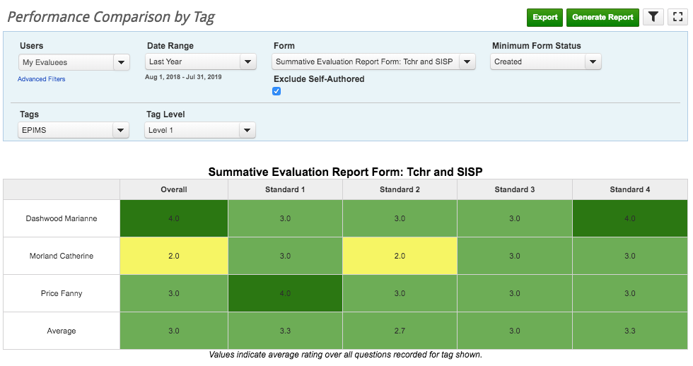
* You are able to export his report to further manipulate the data
Back to top

Search Data

Quick Search
Who can run this report: Teachers, Evaluators, District Administrators
Description: This report is a great way to easily locate all data related to a particular standard. Predefined Tags that System Administrators setup are Dark Blue. Optional Tags that end users choose while filling out a form are Light Blue. You can also click on the title of the form to open it.
1. Click on the title of the form (in blue) and you will be taken directly to the form
2. You can copy and paste directly from this screen into another
3. Save time, you can run a Quick Search while filling out a form, just click on the blue "Actions" button
Filters: User(s), Author, Date Range, Forms, Tags, Data Elements, Question Types
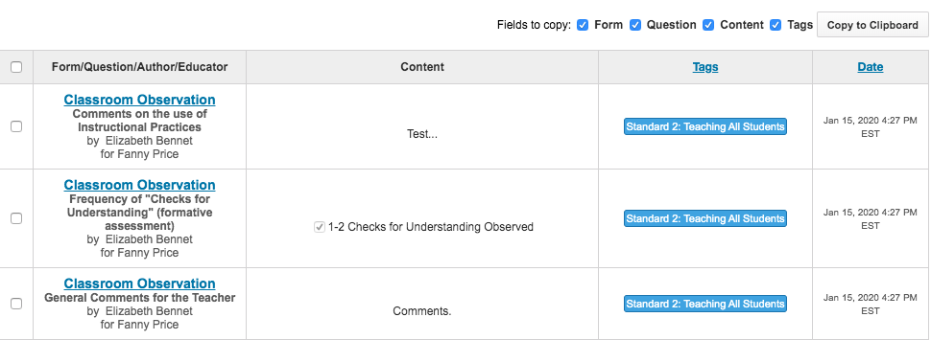
* You can export this report to further manipulate the data
Back to top

Export Form Data
Who can run this report: District Administrators
Description: You have the ability to export form data to Excel or CSV Format. Choose a User, Date Range and Form Name. When you Generate a Report no visual data will appear. In order to download the data please click the 'Export' button.
Filters: User(s), Date Range, Form Name (have to choose one form), Tags
Advanced Filters: School, Subject, Job, Team, Professional Status, Departments
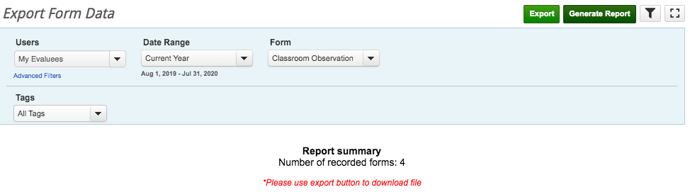
Back to top

Plans

Plan Completess By User Report
Who can run this report: Evaluators, District Administrators
Description: Pull a report of users' progress toward their assigned plan. This report is a similar, non-interactive, version of the Evaluator Dashboard
Filters: Users, Plan, Date Range, Plans Included
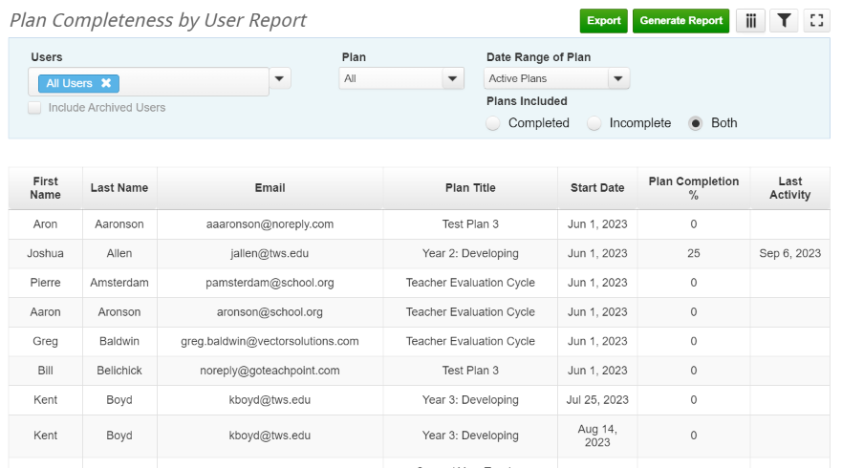
Back to top

User Activity

User Logins
Who can run this report: District Administrators
Description: Pull a list of all users who logged into Vector Evaluations+. Results will show the user's name, the number of times logged in, and the date and time stamp of the most recent login.
Filters: Users, Date Range, and Login Type
